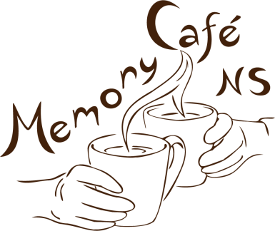[DATE]

Dear [HEALTH CARE PROVIDER’S NAME]

My name is [WRITER’S NAME] and I am writing on behalf of our Memory Café Nova Scotia team in hopes of gaining your support for participant recruitment, as a health care provider local to [INSERT LOCATION].

Memory Café Nova Scotia (www.memorycafens.ca) is a not-for-profit Age-Friendly Communities Initiative affiliated with Dalhousie University Department of Psychiatry. Our goal is to improve social connection and well-being for older adults living with memory challenges and their families and caregivers. We also aim to destigmatize dementia by embedding Memory Cafés in welcoming social spaces right in the community to promote inclusion and understanding of persons living with dementia while also supporting families and caregivers.

Our Memory Cafés series consist of five short gatherings (1 - 1.5 hours, hybrid - in-person or virtual) occurring monthly during the winter and spring. [INSERT DATES AS REQUIRED]. The gatherings occurring this year at [INSERT CAFE NAME] (and other virtual) consist of socialization and interactive engagement through art and music activities designed to promote discussion. [INSERT DETAILS ABOUT ARTISTS&MUSICIANS AS DESIRED]

Your help in recruiting participants and their caregivers/families would be greatly appreciated. We welcome participants of various backgrounds and demographics including any persons living with dementia, with emphasis on including persons/caregivers particularly vulnerable to experiencing social isolation

Please find the attached Registration Form to be completed by the participant/caregiver/family and sent to our local coordinator [INSERT LOCAL COORDINATOR NAME]. You can find more information on the project on our website [https://memorycafens.ca/](https://can01.safelinks.protection.outlook.com/?url=https%3A%2F%2Fmemorycafens.ca%2F&data=04%7C01%7Ccjcurrie%40cbrm.ns.ca%7Cefdb58fa68e7436140e508d95dad771b%7C1b4d30e165de4d3b8dd81e977e816efc%7C0%7C0%7C637643821893815878%7CUnknown%7CTWFpbGZsb3d8eyJWIjoiMC4wLjAwMDAiLCJQIjoiV2luMzIiLCJBTiI6Ik1haWwiLCJXVCI6Mn0%3D%7C1000&sdata=NtKZr4mTA8dUIKjnE0qCRcC99fpgizo4Nd0D3juMb%2Bo%3D&reserved=0). Feel free to email Dr. Beverley Cassidy at [Beverley.Cassidy@nshealth.ca](mailto:Beverley.Cassidy@nshealth.ca) if you’d like to discuss or if you have any questions.

Kind Regards,

[INSERT WRITER’S NAME]

On behalf of the Memory Café Nova Scotia team